DATA ANALYTICS

ASSIGNMENT 2

PCA AND SVD ON IRIS DATASET

TEAM MEMBERS

NAME SRN  
VIMARSHA R PES1201701590

VINUTHA M N PES1201701373

KEERTHI PRIYA P PES1201701643

**PCA**

**Principal component analysis (PCA) is a statistical procedure of dimensionality reduction that uses an orthogonal transformation to convert a set of observations of possibly correlated variables (entities each of which takes on various numerical values) into a set of values of linearly uncorrelated variables called principal components.**

Importing modules and iris dataset

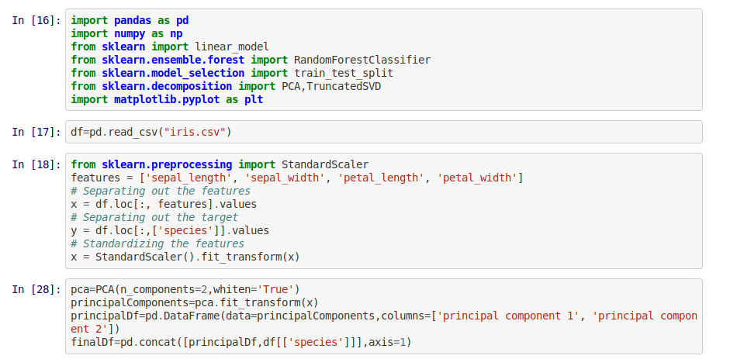

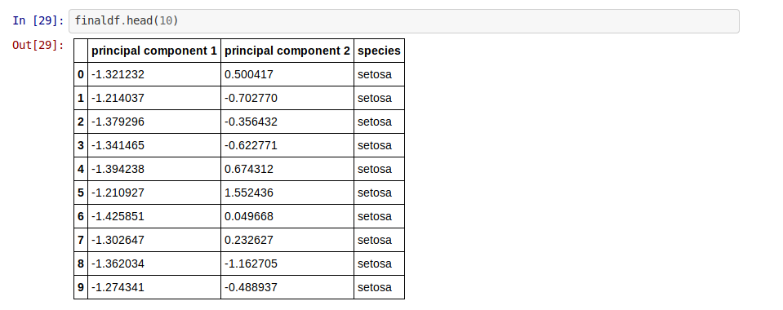

**2 COMPONENT PCA**

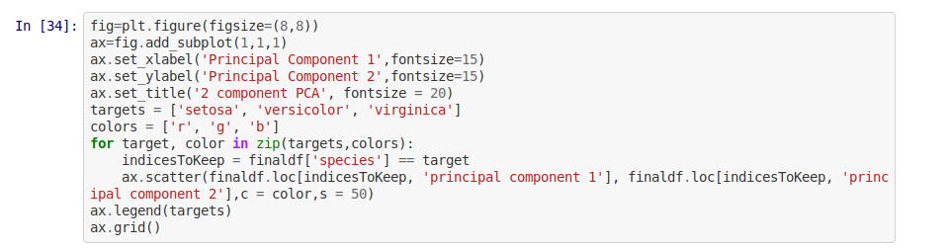

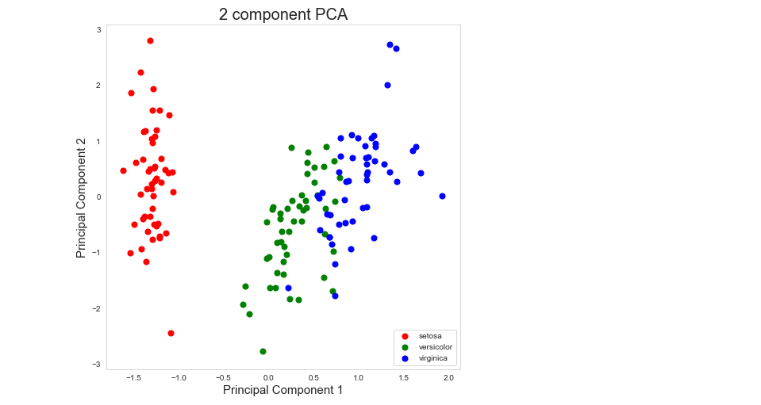

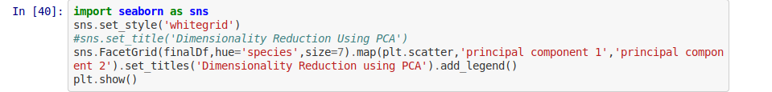

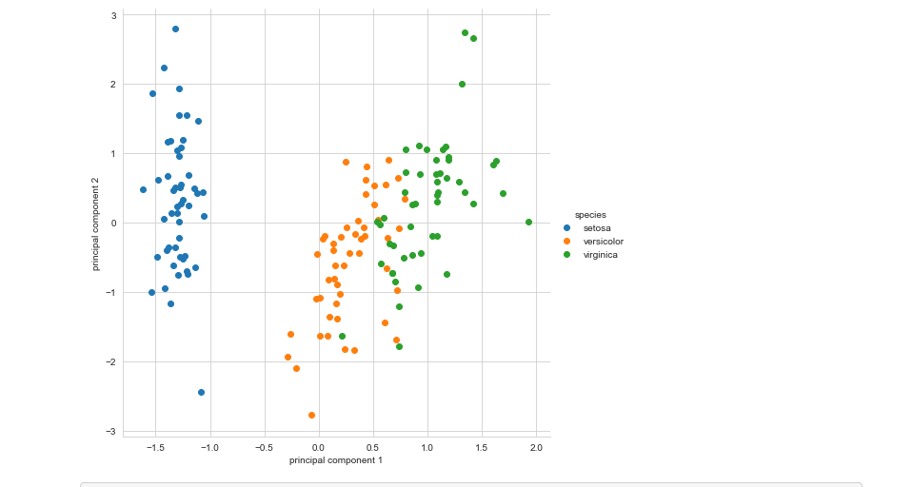

**3 COMPONENT PCA**

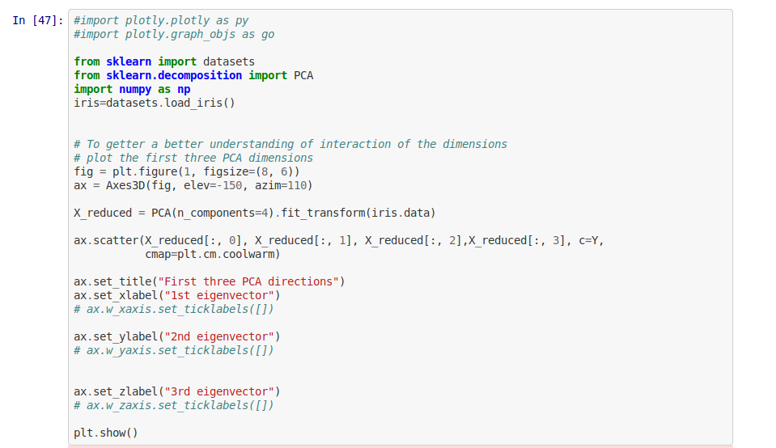

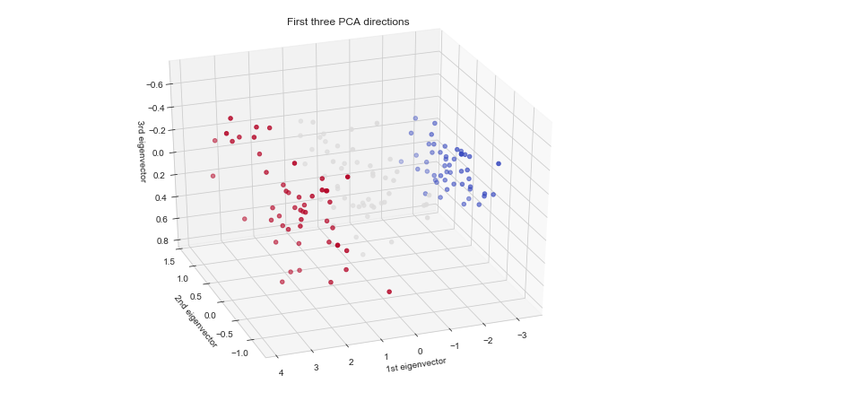

**SVD**

**The singular value decomposition (SVD) is a factorization of a real or complex matrix. It is the generalization of the eigendecomposition of a positive semidefinite normal matrix (for example, a symmetric matrix with non-negative eigenvalues) to any matrix via an extension of the polar decomposition.**

